This document shows the process I used to install and configure a certificate authority in my IA462 Lab. The second part of this document reviews any issues and troubleshooting that took place during the lab.
Install and Configure CA
Get Scripts and Create CA
To start this lab, I ran dnf install git -y in the Linux manager to install Git packages. Then I ran git clone https://github.com/ckriege2/IA-462.git to copy the code from the class repository. I ran vim ssl-script.sh to edit the file and updated the script location to /home/pa-ramey@ia462.advossec.com. I ran the command Chmod 755 ssl-script.sh to be able to write to the directory. Then I entered the file as root and generated a root certificate. Then in the ssl configuration file, I edited the email address to be my own.
I went back into ssl-script.sh and generated a new intermediate CA. In the cnf file I edited the email address again as well as the certificate name to include Pfsense. Then I logged into the pfsense firewall and added a certificate authority named IA462 Root Certificate Authority. I went to System/ Certificate Manager/ Cas and imported the certificate I just created for the firewall. In the temp directory I ran cat IA462.cer to display the contents of the file so I could copy to PFsense.
Back on the Linux Mgr that’s logged into the domain, I entered root to generate the private key by running openssl rsa -in /opt/ssl/IA462/pfsense/private/pfsense.key -out /tmp/pf-nopass.key. I added this private key data to the Certificate Authority in PFsense.
Then in PFsense I created an internal certificate named pfsense-web. I gave it the Common Name of pfsense.advossec.com and made it a Server Certificate. Then I added a few alternative names to the certificate: pfsense.advossec.com, pfsense, 192.168.156.1. Then I went to System/ Advanced and changed the certificate from the default to pfsense-web.
In the Linux manager, I went to Firefox security settings to import the certificates.
Create GPO for CA
I logged into the server as a domain administrator and added a GPO to the domain named Cert-Deploy. I edited the policy to disable user configuration settings. Then I added the root and intermediate certificates to the Cert-Deploy policy.
After that I added Active Directory Certificate Services to the domain administrator account on a newly configured server.

I ran the ssl script again and chose option 6, “sign an external intermediate request”. I named it Windows_cert.cer.
I generated a CRL using option 5 from the ssl script. Then I copied the certificate files over from the IA462-Mgr using scp. I used these files to setup a crl website using IIS to check for old certificates. I made an alias for the crl website in the DNS Manager in case the IP address changed.
Configuring Certificate Authority
I installed the CA certificate on the certificate authority and started the CA. I added the Enterprise PKI snap-in to Microsoft Management Console. I verified that the certificates were displaying an OK status. In the certificate authority, I duplicated services to create names and add templates for my specific domain.
Troubleshooting
Generating Certificate
After generating a new root certificate, the openssl.cnf file was blank. I made sure git was installed by running the install command again, and I also cloned the git directory again. After going through the walkthrough a second time, I realized I did not update the path in ssl-script.sh. After updating the path the certifcate generated correctly.
Configuring PFsense
When I tried to save the private key in the certificate authority on PFsense, it gave the error “The submitted private key does not match the submitted certificate data.” I reinserted both certificates and it let me save the configuration.
Changing the DC Name
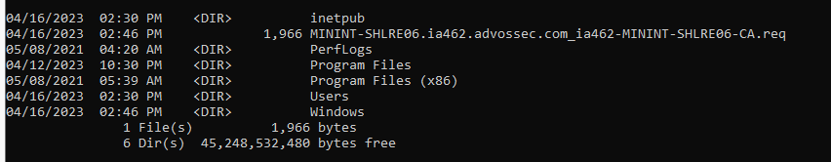
The biggest mistake I made in this lab was changing the domain controller name in the middle of the lab. My certificate was showing up as MINT. Once I changed the name of the domain, I couldn’t even log back into the server. So, I eventually reinstalled and reconfigured my domain controller. When reconfiguring the certificate in PFsense, it kept saying that my certificate and private key didn’t match.
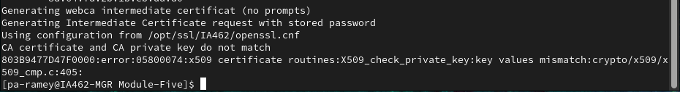
I ran a openssl rsa -noout -modules -in privateKey.key | openssl md5 to see if the MD5 of the certificates matched and it didn’t.

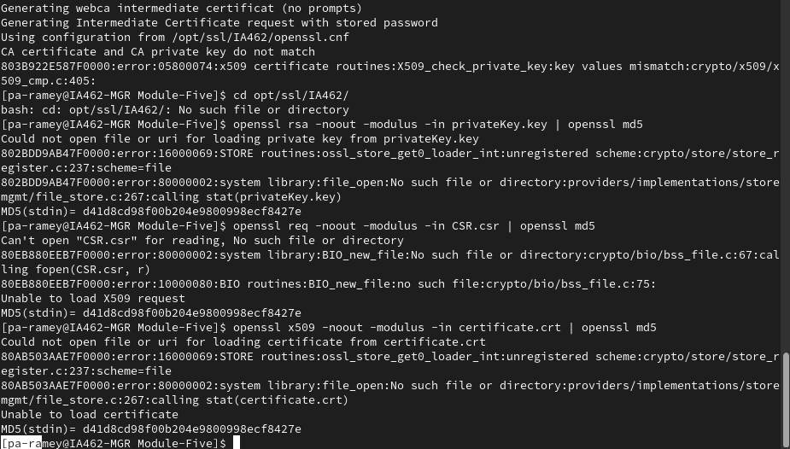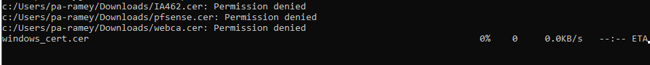
I decided I had to delete the current certificates and regenerate new ones. I was having issues deleting some folders; most folders in the Home directory were locked. It’s good to know that in the Linux manager the private key and certificate are stored in different locations. The certificate was stored in the users account, and the private key was stored in the root account. I changed pa-ramey to owner of home directory and deleted /opt/ssl/. I wasn’t sure if this was going to solve my issue or make it worse. But my certificate end up working in the end.
After having to restart my lab yet again, I decided to create my certificate of authority on another server. If I messed that up, I wouldn’t have to go through setting up the DC again and the CA.
Browser Errors
An issue that may come up while generating and changing certificate authorities is it doesn’t work in the browser even though it was configured correctly. If you're having issues changing the certificate authority in the browser, run updates in the browser then try.
When I changed my domain controller name and reconfigured the certificates, Firefox was no longer opening in the Linux manager. I tried to remove it and was not successful. I ran sudo dnf remove firefox and the program was still showing up in the Linux manager. I deleted the firefox folder as well, and the program was still showing in the GUI. I could not successfully resinstall Firefox but did some research on further steps to take to delete. Along with deleting .mozilla/firefix/ from the home directory, you would also need to delete /etc/firefox/, /usr/lib/firefox/ and /usr/lib/firefox-addons/ and /.cache/mozilla.

Failed Validation
When there are multiple trusted certification paths to root CAs, you could get an error that the security certificate is not trusted by a trusted certificate authority. The user can still access the website after clicking “Continue to this website (not recommended)”. To work around this issue, you would just need to disable one of the root certificates. This may become an issue when generating your own root certificates, not using the IA462 Lab’s certificate script.

Misconfigured Wildcard Certificate
When configuring a certificate of authority for your domain controller, you will want to include the wildcard symbol. This way, the certificate can secure multiple sub domain names on the same base domain. It should look something like *.advossec.com.

